This n That

An e-mail newsletter from Agapé Athletics Club

Editor: Marieta Bortoli 082 466 7031 22 October 2018 www.agape.org.za

E-mail: marietabortoli@gmail.com

NB

- Next league race – Tom Jenkins – 17 November
- Agapé AGM – 17 November

Editorial

Attached please find our AGM notice. If you are or know of someone who is willing to serve on the Executive Committee, please let me know as we have quite a few vacancies for next year.

Please remember to RSVP your attendance to the AGM.

Notice Board Additions

◊ Tom Jenkins Run/Walk Challenge

Attachments

□ AGM notice

Birthday Greetings

May God look down and bless you now when your birthday’s here and keep you in His loving care each day throughout the year, and may He grant you happiness in everything you do – today, tomorrow, always, every day your whole life through!

Craig Gainsford 25 October | Roald le Roux 31 October

Personalia

Welcome new and former members

Congratulations

Congratulations to the following members:
Thank you’s

In the mailbox

General
Clothing available:
Buffs @ R100
Ladies skirts @ R200
Second skins @ R220
Age tags @ R30

Please contact Marietjie if you wish to purchase some of the items:
Cell: 072 541 7268 E-mail: ventermarix9@gmail.com
The items will also be available at races, please visit our gazebo

Race reports/Upcoming race information

Race report feedback CSIR 20 October 2018, 10 km (Elbert Loubser):
Woke up to a warmish morning. No jacket needed today. Approaching the CSIR A-frame main gate entrance via Lynnwood road, travelling North on the M16 (Meiring Naude Rd), Ken Swettenham was already in attendance, directing and 'filtering' traffic. Fortunately, his task was made much easier with the huge yellow barriers.  Marshalling at such a critical entrance point and regulating access is quite a challenge at the best of times.

Parking is ample outside the CSIR property (which includes a +- 10-minute brisk walk from the Innovation Hub), one needs to plan ahead though, as the Starting point and Finish are a couple of hundred meters North in Yellow-wood Rd (inside the CSIR premises). Lovely green lawns and plenty of shade for the gazebos. I found that I was overdressed with my second-skin, as it was getting even warmer. Hmmm, very little cloud cover and a tad humid.

Today I heard the start gun as the 10 kay and 21.1 kay races were set off at 06:00, direction North on the huge circular Yellow-wood Rd. Nice and flat so far. Left into Hadida Rd, out through the CSIR Eastern gate, short left and right into Kesselaar Ave. We curve clock wise on Brummeria Rd, Mispel Ave and eventually arrive back at the Eastern gate. 'Then the trouble started!', that infamous 'trail' climb up towards the CSIR Telkom tower. Be cautious on this section (especially where it flattens out and starts ascending), as protruding rocks and loose stones catch one unawares on the uneven surface, the moment one's concentration wavers. Left into Steenbok (South section of the CSIR), circle back up towards Steenbok, cresting on Duiker Rd (just before the CSIR Squash Club). Now the hard work is done!

Lovely downhill on Duiker Rd, a loop on part of Yellow-wood Rd and another loop on Strelitzia Rd, which takes us to the Finish just off on the grass in the vicinity of the CSIR Knowledge Commons.
The refreshment table an appreciated sight with cold Coke and water, as by now the heat was being turned on seriously by mother nature.

Another pleasant (except for that hill :-)) and well organised race. Thank you CSIR club.

A BIIIIIIIG Thank you to Hennie Venter and Marix Venter for the Gazebo base camp. Lovely cake on offer afterwards.

Agapé greetings.

Race Results
CSIR (AGN) 10km race - 2018-10-20
Position | Initials | Surname | Sex | Age | Finish Time
134 | D | De Beer | M | 46 | 00:51:32
141 | M | Cronje | F | 17 | 00:51:50
216 | E | Dirkse Van Schalkwyk | F | 43 | 00:56:25
231 | B | Cronje | F | 40 | 00:56:54
292 | L | Fourie | M | 73 | 00:59:05
593 | G | Hughes | F | 70 | 01:07:59
699 | A | Kruge | M | 71 | 01:10:06
718 | D | Molabe | M | 17 | 01:10:35
743 | H | Venter | M | 59 | 01:11:21
814 | A | Albin | F | 47 | 01:13:03
845 | C | Mouton | F | 61 | 01:13:57
1028 | A | Te Reh | M | 69 | 01:17:58
1116 | R | Sher | M | 75 | 01:20:03
1166 | K | Nurden | M | 83 | 01:21:31
1441 | E | Loubser | M | 61 | 01:31:01
CSIR (AGN) 21km race - 2018-10-20
Position | Initials | Surname | Sex | Age | Finish Time
65 | K | Booyse | F | 35 | 01:37:53
87 | K | Imrie | M | 46 | 01:41:52
145 | W | Kiewitt | M |  | 01:46:47
179 | E | Meyer | F | 46 | 01:49:33
200 | S | Brink | M | 48 | 01:51:31
212 | C | De Kiewit | M | 59 | 01:52:39
226 | S | Marais-werner | F | 44 | 01:53:10
452 | W | Reinecke | M | 44 | 02:03:22
547 | M | Brummelkamp | M | 39 | 02:07:48
705 | M | Atkins | F | 49 | 02:13:40
752 | D | Strydom | M | 38 | 02:15:03
753 | W | Focaraccio | F | 36 | 02:15:10
806 | G | Vermaak | M | 38 | 02:17:29
877 | T | Oelofse | F | 44 | 02:19:44
892 | H | Greyling | M | 49 | 02:20:25
1110 | V | Vermaak | F | 38 | 02:29:57
1150 | R | Le Roux | M | 63 | 02:33:10
1151 | W | Weder | M | 70 | 02:33:10
1183 | A | Lenoge | F | 45 | 02:34:55
1312 | M | Venter | F | 59 | 02:43:22
CSIR Helpers (AGN) 10km race - 2018-10-20
Position | Initials | Surname | Sex | Age | Finish Time
6 | C | Burger | M | 54 | 00:55:43
CSIR Walk (AGN) 10km race - 2018-10-20
Position | Initials | Surname | Sex | Age | Finish Time
3 | G | Brink | M | 51 | 00:57:53
18 | J | Barkhuizen | M | 48 | 01:14:08

League results

Training/Health snippets

6 Ways to Become a Faster Runner Without Running a Step
Runners are a hardworking lot, so the promise of “free speed” often strikes us as empty, and maybe even a touch offensive. However, once you get runners talking about improvements they have made in their training, gear or diets, they are usually eager to share the discoveries that have helped improve their performances. That’s the goal with this article—to share some well-documented techniques that could help you get faster, beyond the obvious (and undeniably effective) advice to run more miles and train harder.

Wear Lighter Shoes
Researchers have established that reducing the shoe weight by 100 grams typically yields about a 1 percent increase in performance. That’s a pretty big gain that could be especially noticeable over longer distances. However, like most of the tips in this guide, there are some limitations to keep in mind—not every runner will benefit from switching to racing flats or other super-light shoe models. If the cushioning or shoe stability is inadequate you will lose efficiency and give back any potential performance gains.
RELATED: Are Racing Flats Right for You?

Get a Proper Warm-up
“Ninety percent of success in running comes down to a willingness to work hard and sacrifice, and being consistent,” Coach Alan Culpepper recently wrote. “The other 10 percent comes down to areas like diet, hydration, stretching and injury prevention. A proper pre-run warmup routine is part of that 10 percent. It might seem inconsequential, but it can make or break a race or hard workout.” Read Coach Culpepper’s warmup advice here.
RELATED: The Mattock Dynamic Warm-up for Runners

Lose Unwanted Bodyweight
Like our first tip about the potential speed gains from reducing shoe weight, it’s proven that reducing excess bodyweight can help make runners faster—but only to a point. “Each runner has an optimal racing weight,” writes Matt Fitzgerald, the author of Racing Weight, How to Get Lean for Peak Performance. “I define this as the weight at which a runner performs best in races. Because runners are more often above their optimal racing weight than right at it, they tend to associate losing weight with gaining performance. This association leads some runners to make weight loss their primary focus and to push performance into the background.” Simply put, losing a few pounds could make you faster, but losing too much weight will make you slower, and potentially lead to other health issues.
RELATED: For Runners, Not All Weight Loss is Good Weight Loss

Add Plyometric Exercises
We said we could make you faster without running more, but we didn’t say anything about adding leaping, bounding and jumping to your training. Multiple studies have shown that adding plyometric exercises to runners’ normal routines produces gains in both speed and endurance. The speed part makes sense intuitively—the explosive nature of plyometrics clearly translates to better top-end running speed. But keep in mind that as your explosive power increases your running economy and endurance usually improves too.
RELATED: The Benefits of Plyometrics for Runners

Crank Up the Tunes
Another point that running researchers agree on is that there is a sweet spot of about 180 steps per minute that most elite runners meet or even exceed. A faster cadence leads to better efficiency and reduces the chance that you are over striding. So, how do you boost your running cadence toward this mark? Try making a playlist with songs like these 15 tunes—they will pace your footsteps with 180 beat-per-minute rhythms.

Stop Running
Perhaps you’re reading this story because you’re feeling a bit desperate to get faster. You’re hitting your target mileage, and sometimes more, every week. You give your all-in speed work and other demanding training sessions, but without seeing the results you’re hoping to achieve. If those scenarios sound familiar you are a prime candidate for becoming over trained. “While the signs and symptoms of overtraining aren’t overt, it is possible to identify which activities present the greatest danger to overtraining, recognize subtle signs that suggest you’re approaching the precipice, and discuss how to come back if you believe you are over trained,” writes running coach and author Jeff Gaudette.

Overtraining: Why it happens, how to spot it & how to dig yourself out

Digging Yourself Out
While I’ve spent a good amount of time discussing the causes and symptoms of overtraining, the treatment will be much shorter. You’ve probably even guessed it already–rest. If you’re over trained, you need to focus on rest and recovery.

How long to rest?
Researchers and coaches vary on the exact amount of time you’ll need to fully recover from a bout of overtraining. Primarily, the rest period will depend on how severe your symptoms are and how quickly your body responds. I suggest taking at least three weeks before you even think about running again. More than likely, you’ll need at least 6-8 weeks of complete rest before you’re full recovered. It’s critical that you listen to your body and be patient or you’ll find yourself right back in an over trained state within a matter of weeks.
Speeding up the process
To speed the recovery process up, you should continue to focus on maintaining a healthy diet–eating nutritious food and eating plenty of them, as well as the typical recovery protocols such as stretching, massages, and getting plenty of sleep.
By educating yourself about the most common causes of overtraining and recognizing the symptoms early, you can prevent yourself from stagnating in training and setting yourself back weeks, if not months.

Your thought for the week

Better to get hurt by the truth than comforted with a lie

Your smile for the week

Bible summary by a six-year-old:
In the beginning, which occurred near the start, there was nothing but God, darkness, and some gas. The Bible says, 'The Lord thy God is one, but I think He must be a lot older than that.
Anyway, God said, 'Give me a light!' and someone did. Then God made the world.
He split the Adam and made Eve. Adam and Eve were naked, but they weren't embarrassed because mirrors hadn't been invented yet.
Adam and Eve disobeyed God by eating one bad apple, so they were driven from the Garden of Eden ... Not sure what they were driven in though, because they didn't have cars.
Adam and Eve had a son, Cain, who hated his brother as long as he was Abel.
Pretty soon all of the early people died off, except for Methuselah, who lived to be like a million or something.
One of the next important people was Noah, who was a good guy, but one of his kids was kind of a Ham. Noah built a large boat and put his family and some animals on it. He asked some other people to join him, but they said they would have to take a rain check.
After Noah came Abraham, Isaac, and Jacob. Jacob was more famous than his brother, Esau, because Esau sold Jacob his birthmark in exchange for some pot roast. Jacob had a son named Joseph who wore a really loud sports coat.
Another important Bible guy is Moses, whose real name was Charlton Heston. Moses led the Israel Lights out of Egypt and away from the evil Pharaoh after God sent ten plagues on Pharaoh's people. These plagues included frogs, mice, lice, bowels, and no cable.
God fed the Israel Lights every day with manicotti. Then he gave them His Top Ten Commandments. These include: don't lie, cheat, smoke, dance, or covet your neighbour’s stuff.
Oh, yeah, I just thought of one more: Humour thy father and thy mother.
One of Moses' best helpers was Joshua who was the first Bible guy to use spies. Joshua fought the battle of Geritol and the fence fell over on the town.
After Joshua came David. He got to be king by killing a giant with a slingshot. He had a son named Solomon who had about 300 wives and 500 porcupines. My teacher says he was wise, but that doesn't sound very wise to me.
After Solomon there were a bunch of major league prophets. One of these was Jonah, who was swallowed by a big whale and then barfed up on the shore.
There were also some minor league prophets, but I guess we don't have to worry about them.
After the Old Testament came the New Testament. Jesus is the star of The New. He was born in Bethlehem in a barn. (I wish I had been born in a barn too, because my mom is always saying to me, 'Close the door! Were you born in a barn?' It would be nice to say, 'As a matter of fact, I was.')
During His life, Jesus had many arguments with sinners like the Pharisees and the Democrats.
Jesus also had twelve opossums. The worst one was Judas Asparagus. Judas was so evil that they named a terrible vegetable after him.
Jesus was a great man. He healed many leopards and even preached to some Germans on the Mount.
But the Democrats and all those guys put Jesus on trial before Pontius the Pilot. Pilot didn't stick up for Jesus. He just washed his hands instead.
Anyways, Jesus died for our sins, then came back to life again. He went up to Heaven but will be back at the end of the Aluminum. His return is foretold in the book of Revolution.

Something to ponder over / something spiritual
Sometimes asking ourselves the right questions can do a lot to help us see life from a whole different perspective.
There are some questions that can be life-changing, if we raise them, contemplate on them, and try to answer them. This, however, can be achieved only if we ask those questions with full honesty.
Here are a few such questions to ponder:
- If you were going to die tomorrow, what would you do today?
- If you had the opportunity to be different, what would you change about yourself?
- If you could change one thing in the world, what would it be?
- If you could choose to live anywhere in the world, where would you prefer to live?
- If you could commit any crime and get away with it, what would you do?
- What would you do if you found the wallet of your next-door neighbour who you hated?
- If you could have any car you wanted, which car would you choose? Would it be practical or flashy?
- If you could be famous (a household name), what would you like to be famous for?
- If you had one wish, what would you wish for?
- If you could do any job, what would you like it to be?
- If you were asked to speak to a graduating class, what would you say?
- If you were given a choice between being given great wisdom or great wealth, which would you choose?
- If you were given the opportunity to be born again, how would you change how you lived?
- If you were walking through the forest and you suddenly saw a tiger, what would you do?
- If you were told you had a terminal illness and had six months to live. What three things would be most important for you to do?
- If you could say a sentence which the whole world could hear, what would you say?
- If you were given a choice to live as long as you want, how long would you like to live?
- If you could only see three people for the rest of your life, who would they be?

Cancelled Races

Live Running – 1 Dec 2018
Wonderful run -15 December 2018

Notice Board

Useful Links:
www.raceresults.co.za/flyers - for the latest race pamphlets
www.agn.co.za/#League for the latest league logs and the league points you earned
http://www.agn.co.za/Docs/2018/Walking/AGN%20road%20walking%20stds%20ref%20685.pdf
AGN 2017 RW qualifying standards and selection criteria
www.runawaysport.co.za Run-A-Way Sport’s web site
www.verticalhorison.co.za Trail Running www.trailseries.co.za Trail Running
http://www.mastersathletics.net/Age-Graded-Calculator.2595.0.html Age Graded Calculator
http://www.sportsinjuryclinic.net/symptom-checker By clicking where it hurts then ticking which symptoms most apply to you we can give you an indication of what injuries may apply.

Saturday 27 October Irene Farm Race 21.1/10/5 km
Race Organisers: Irene Athletics Club
Venue: ARC Irene Campus, Nellmapius Drive, Irene

 | 21.1 km | 10 km | 5 km
Entry fee | R 90 | R 70 | R50
Entry fee 60 – 69 – race day only | R 50 | R 50
Entry fee 70+ - race day only | Free
Start Time | 06:00 running  05:45 walking |  | 06:00
Cut-off | 03:30 | 02:00

There will be a kiddies 1km race starting @ 08:00 @ R10

Parking also available at Denel

No pets

No iPods or listening devices are allowed

Pre-entries at: Run-A-way Sport; Sweatshop Southdowns, Dunkeld, Bedfordview

www.entrytime.com

League Race
Saturday 17 November Tom Jenkins Run/Walk Challenge 21.1/10/5 km
Race Organisers: Arcadia Running Club
Venue: Pretoria Union Buildings, Church Street Arcadia
GPS: S 27.7402 E 28.2102

 | 21.1 km | 10 km | 5 km
Entry fee | R 90 | R 70 | R50
Start Time | 06:00 |  | 06:20
Cut-off | 03:30 | 02:00

No pets

No iPods or listening devices are allowed

Pre-entries at: Run-A-way Sport; Sweatshop Southdowns; Tshwane Running Shop

www.entrytime.com

2018 AGN LEAGUE FIXTURE LIST
EVENT | DISTANCE | DATE | LEAGUE
 |  |  | RR | RW
Tom Jenkins | 21.1/10 km | 17/11 | X | X

Masters Athletics Fixture list

Local meetings
10 November 2018 Free State Bloemfontein

South African Championships
3/4 May 2019 Oudtshoorn

Africa Champs
December 2018 Africa Championships Tunisia

International Championships
24-30 March 2019 WMA Indoor Torun, Poland
28/9-6/10 2019 30th Summer universiade Naples, Italy
20/7/2020 – 1/8/2020 World Masters athletics Champs Toronto, Canada

Time Trials:

Centurion - Wednesdays at 17:30
Lewende Woord Centurion
Contact Marinda 654 5800 (h) / 082 720 9017

Rietondale - Thursdays 17:30
North Street, Rietondale (Rietondale Park in the street before the Crawford Stadium)
Contact Hennie Venter 082 676 6792

Zita Park - Tuesdays at 17:30
Zita Street, Zita Park, Garsfontein
Contact Hennie Venter – 082 676 6792 Marietjie Venter – 072 541 7268

Gazebo Enquiries

Hennie Venter – 082 676 6792 Marietjie Venter – 072 541 7268

Intercessor:



Fred Harding 076 777 7786

Agapé Executive 2017/2018

Name | Position | Telephone number | E-mail address
Marieta Bortoli | Chairperson & editor | 012 331 2089  082 466 7031 | marietabortoli@gmail.com
Hennie Venter | Registrar, club captain & Vice-chairperson | 082 676 6792 | henniev@seng.co.za  join@agape.org.za
Marilett Jenkins | Secretary | 082 837 2142 | marilett.jenkins@mervitzmalan.co.za
André Breytenbach | Treasurer | 083 566 1090 | andreb@geoscience.org.za
De Wet de Beer | PRO | 082 373 2987 | dewet@styletechnique.co.za
 | Race organiser
Fred Harding | Intercessor | 076 777 7786 | fwhard@gmail.com
Marix Venter | Clothing co-ordinator | 072 541 7268 | Ventermarix9@gmail.com
Suzette van Staden | General activities | 083 290 6280 | suzettevs971220@gmail.com
Gustav Brink | Statistician | 083 417 8431 | gustav.brink@gmail.com

Photo corner

Agapé Executive

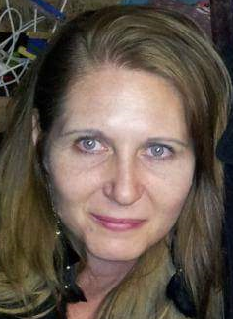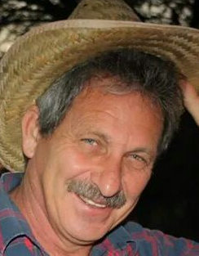
Marieta Bortoli Marilett Jenkins Hennie Venter

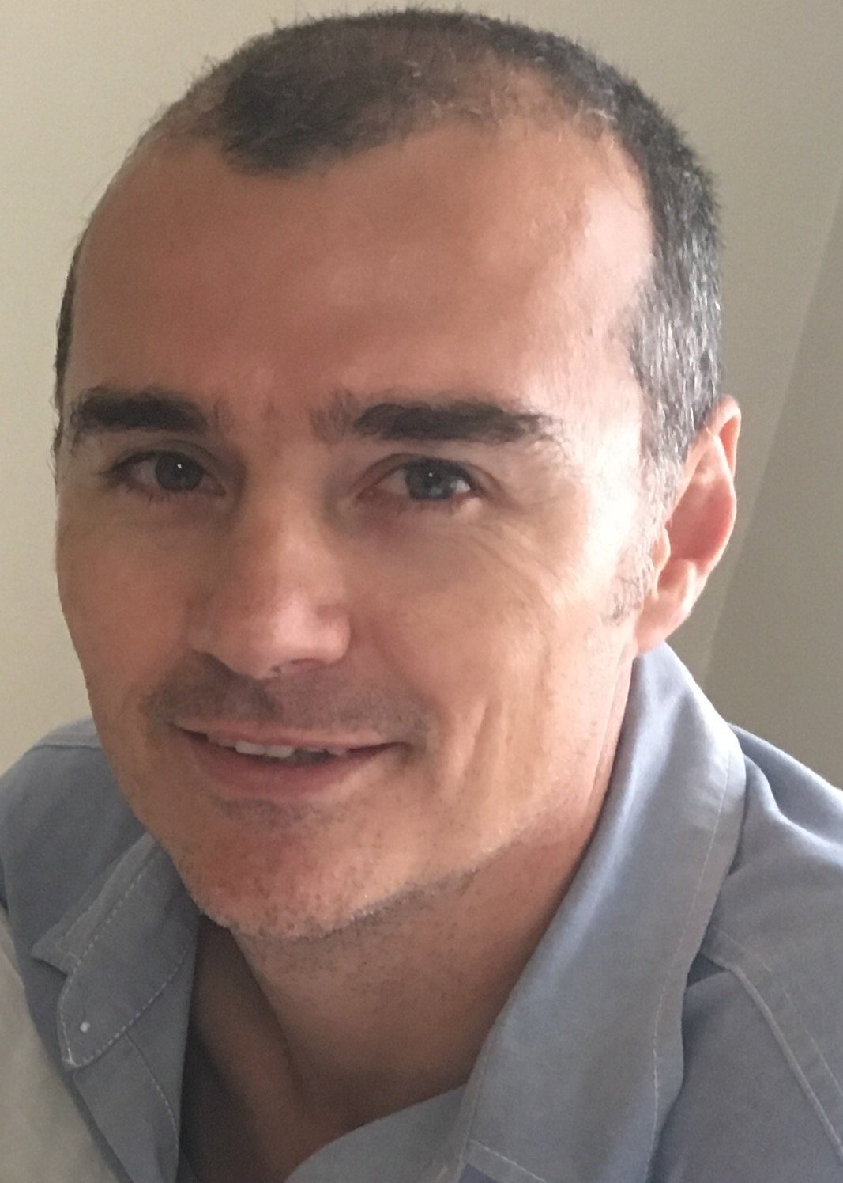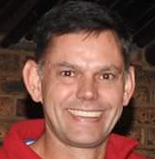
De Wet de Beer André Breytenbach Marix Venter

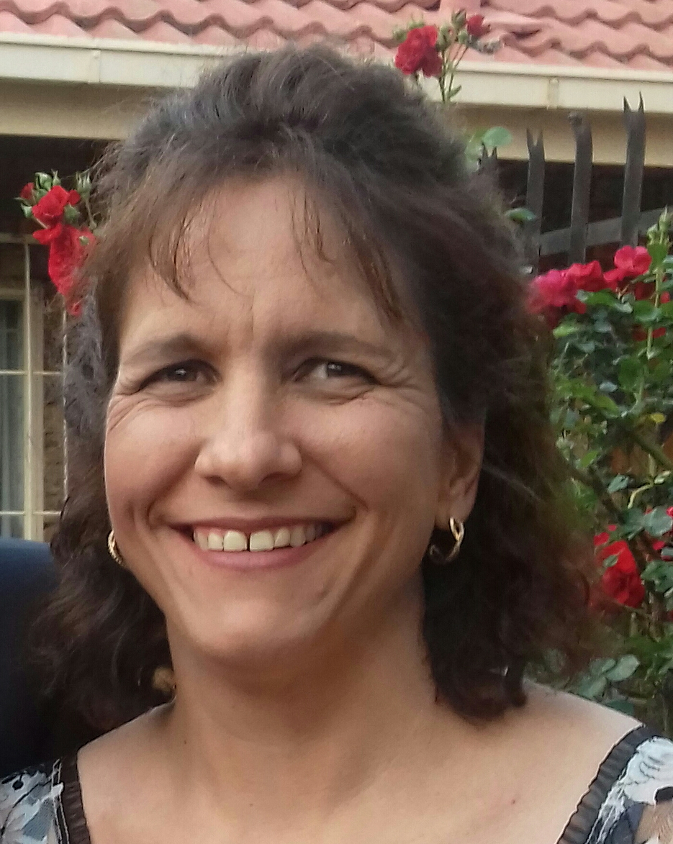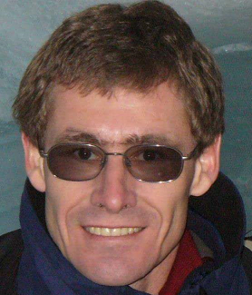
Fred Harding Suzette van Staden Gustav Brink (Ex-officio)

Photos taken at CSIR race

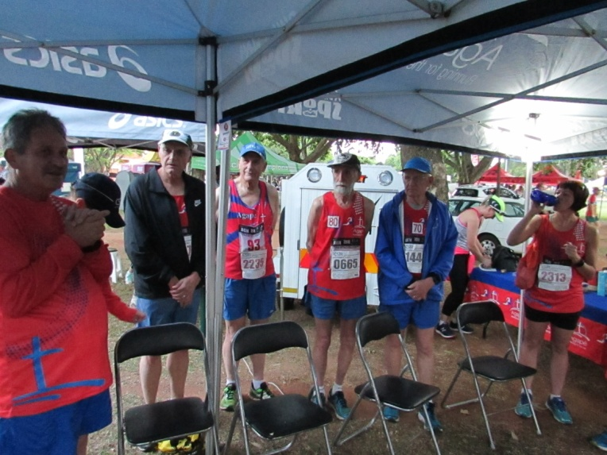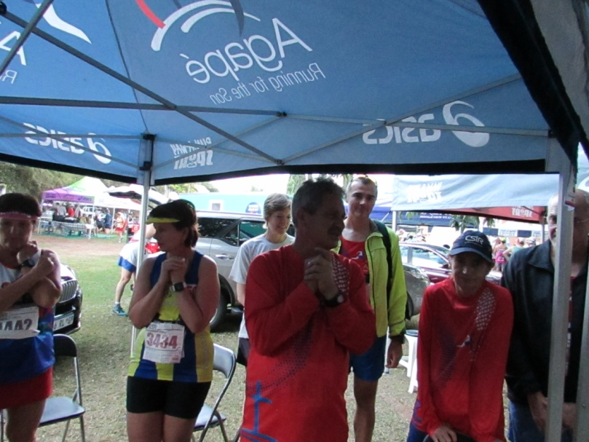

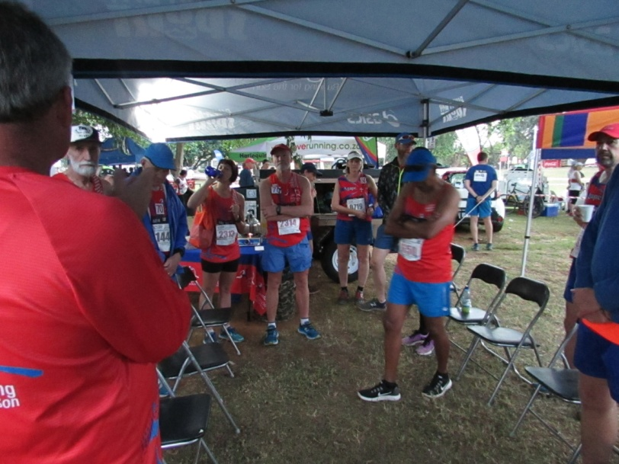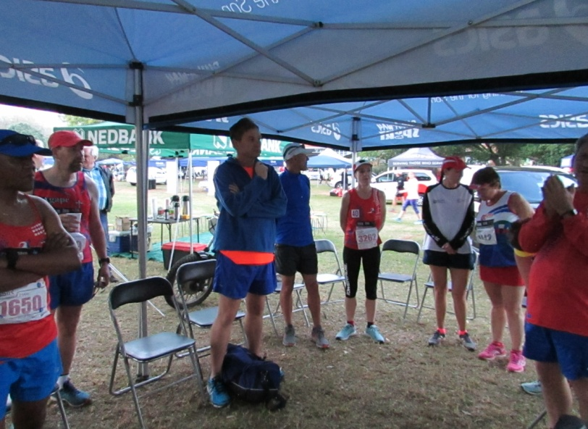

After I mentioned to Gina that her AGN number 174,
corresponded with one of my Dawn-2-Dusk permanent
numbers (119 with Ken Swettenham of the CSIR Club and
174), Gina took this photo. Notice, 174 has double laurel Lammie Fourie receiving a gold medal
leaves as Marie van Dyk (Irene) and I have done 8 together (photo courtesy from Gina)
as a team.
